Psychedelic divide: Lawmakers clash with FDA
By BEN LEONARD and CHELSEA CIRRUZZO

08/05/2024 10:00 AM EDT

DRIVING THE DAY
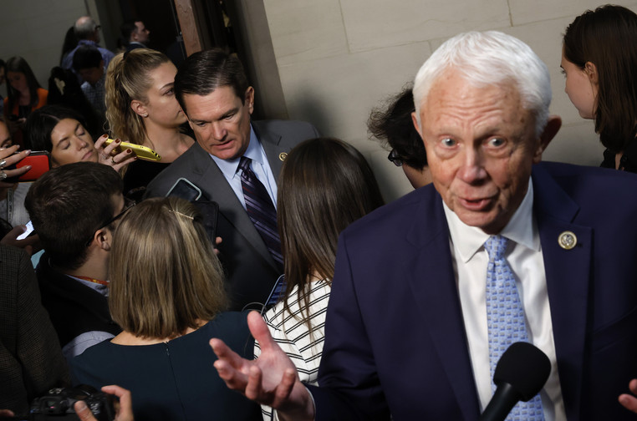
Rep. Jack Bergman sees promise in psychedelic therapy for veterans with post-traumatic stress disorder. | Chip Somodevilla/Getty Images
MDMA GETS A BIPARTISAN BOOST — A bipartisan group in Congress, led by an unlikely front man, Rep. Jack Bergman (R-Mich.), a three-star retired Marine Corps general, is waging a psychedelic drug pressure campaign on the Food and Drug Administration, POLITICO’s Erin Schumaker reports.
Bergman’s ask to the FDA: Consider the science. Then approve Lykos Therapeutics’ application for MDMA — also known as ecstasy — with talk therapy to treat post-traumatic stress disorder.
“Every day that goes by that research isn’t being done, that’s more lives being lost, primarily to suicide,” Bergman, who, with Democrat Lou Correa of California, co-chairs the Psychedelics Advancing Therapies Caucus, told Erin. “A lot of those veterans are on a dark path.”
Decades have passed without a new PTSD treatment, and available options are notoriously ineffective. Meanwhile, high suicide rates among veterans suggest the government isn’t doing enough to help them.
The PATH caucus has been busy as of late. They’ve held press conferences and met separately with Lykos CEO Amy Emerson and the VA’s undersecretary for health’s office. Today, 50 bipartisan members in the House and Senate are sending letters to President Joe Biden and FDA Director Robert Califf, arguing that the FDA should fast-track approving the treatment.
Trouble in paradise: To approve Lykos’ application, the agency must override a “no” recommendation from an independent advisory committee, which voted 9-2 in June against the effectiveness of the Lykos’ regimen and concluded by 10-1 that the therapy’s risks outweigh its benefits.
An FDA rejection of the application would likely curtail the burgeoning psychedelic revolution — drug companies are studying several other psychedelic drugs as potential mental health treatments — while a green light would propel more research. But given the advisers’ opposition, the advocacy from lawmakers and their outside allies would likely raise questions about whether the agency bowed to a pressure campaign.
What’s next? The FDA has set a target date of Aug. 11 to decide whether to approve Lykos’ application.
WELCOME TO MONDAY PULSE. This might be controversial, but the new hot food vending machine in the Cannon House office building looks pretty good. Reach us and send us your tips, news and scoops at bleonard@politico.com or ccirruzzo@politico.com. Follow along @_BenLeonard_ and @ChelseaCirruzzo.

IN CONGRESS

The Congressional Budget Office says that PBM and health insurer mergers could mean higher insurance premiums for some patients. | Eric Gay/AP
CBO PROBES PBM-INSURER TIES — Insurers merging with pharmacy benefit managers — companies that manage prescription drugs for health insurers — doesn’t necessarily lead to lower premiums for enrollees, the Congressional Budget Office says.
In response to a question for the record from House Budget Committee Chair Jodey Arrington (R-Texas), the scorekeeper said that such vertical integration could align incentives for PBMs and insurers, which can lead to lower prices for drug spending in such health plans. However, the CBO said that drug costs and premiums increase for other insurers using the PBM.
“Any reductions in spending by the newly integrated plan may not be passed on to the plan’s enrollees in the form of lower premiums,” the CBO wrote late last week.
The Pharmaceutical Care Management Association, a PBM lobbying group, slammed the findings.
“Despite CBO’s predetermined assumptions, the evidence is clear that the PBM market is highly competitive, and PBMs have a proven track record of lowering drug costs for everyone,” spokesperson Greg Lopes said.
Zooming out: The CBO’s findings come as Congress tackles consolidation in the health care sector and looks to reign in PBMs’ practices in an end-of-year package.
Three PBMs — CVS Caremark, Express Scripts and OptumRx — control more than three-quarters of the market.
Congress is weighing a number of PBM reforms to reduce health care spending, including requiring more transparency and policies that would “delink” PBMs’ service fees from a drug’s list price. The CBO said that delinking is likely less effective than transparency because PBMs could work around delinking requirements if they weren’t required to report information on prices and fees.
“The converse would also be true: The information disclosed to a payer under a PBM transparency policy would be more useful if payments from manufacturers to PBMs were delinked from drug prices or spending,” the CBO wrote.

PHARMA WATCH
‘AVAILABLE’ BUT ‘IN SHORTAGE’ — The FDA says that all dosages of Eli Lilly’s drugs treating diabetes and obesity are available — but the agency has the injections still labeled on its website as “currently in shortage,” POLITICO’s Lauren Gardner reports.
That difference is key for compounding pharmacies that make copycat versions of the drugs. The FDA sanctions compounding when a product is in shortage.
For the FDA to move a treatment off the shortage list, it must determine that all manufacturers can meet demand and verify that each company has enough supply, an FDA spokesperson said.
“‘Available’ doesn’t amount to a hill of beans,” said Scott Brunner, CEO of the Alliance for Pharmacy Compounding.
FDA spokesperson Amanda Hils said the agency is working with Lilly to assess the drug supply’s stability, adding that regulators consider a drug to be in shortage “when the total supply of all versions of a commercially available product cannot meet the current demand.”
The bigger picture: Lilly’s blockbuster GLP-1 drugs, Mounjaro and Zepbound, have been in shortage for close to two years as demand has gone through the roof.
Counterfeit versions and poorly made compounds have entered the market, drawing warnings from the FDA and lawsuits from Lilly and GLP-1 competitor Novo Nordisk against pharmacies and websites they say are illegally marketing their wares.
A spokesperson for Lilly didn’t respond to a request for comment.

COVID
A NEW ‘MOONSHOT’ — Sen Chair Bernie Sanders (I-Vt.) is pushing new legislation that would boost NIH funding to address long Covid.
The Long Covid Research Moonshot Act, backed by Sanders and five Democrats, would mandate that NIH create a long Covid database and provide $1 billion in annual funding for a decade to support research and treatment.
“For far too long, millions of Americans suffering from long COVID have had their symptoms dismissed or ignored — by the medical community, by the media, and by Congress,” Sanders, chair of the Health, Education, Labor and Pensions Committee, said in a release. “That is unacceptable and has got to change.”
The bigger picture: In 2022, the CDC estimated that 1 in 13 U.S. adults had long Covid symptoms. The condition is difficult to diagnose since no test can confirm it. Patient advocates have pushed Congress for more research and funding.
The path forward: The legislation is by far the most significant effort yet to address long Covid in Congress, at least in terms of spending. Given the price tag and that no Republicans have signed on, it likely faces long odds of becoming law in its current form.

